In App store, install the Blynk app.

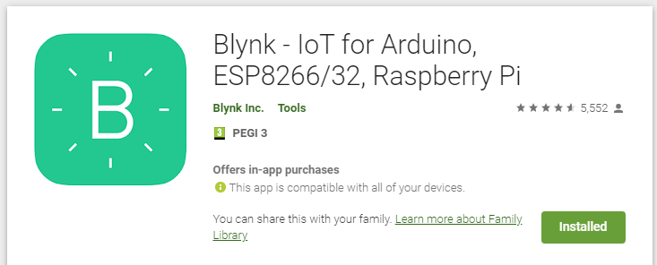
Go through the steps to create the account , and start a new project.

An Authentication token will be sent to you by email.

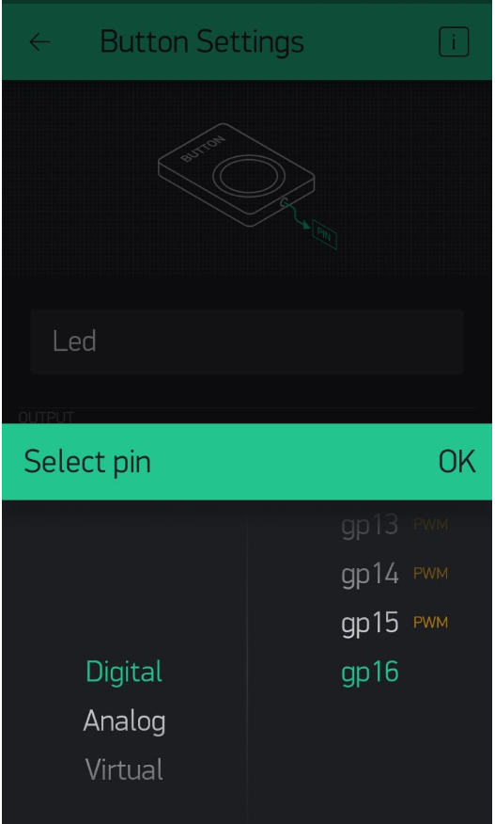
In the phone app, add a new Button and assign it pin 16 (where the BUILTIN_LED is connected on the board).

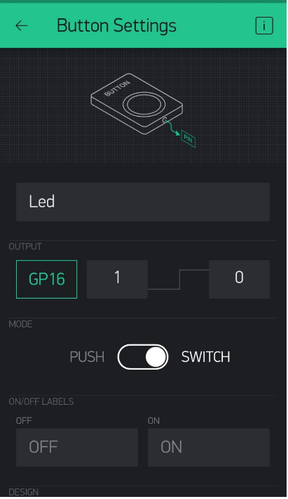

In the Arduino IDE, go to : Sketch → Include Library → Manage Libraries

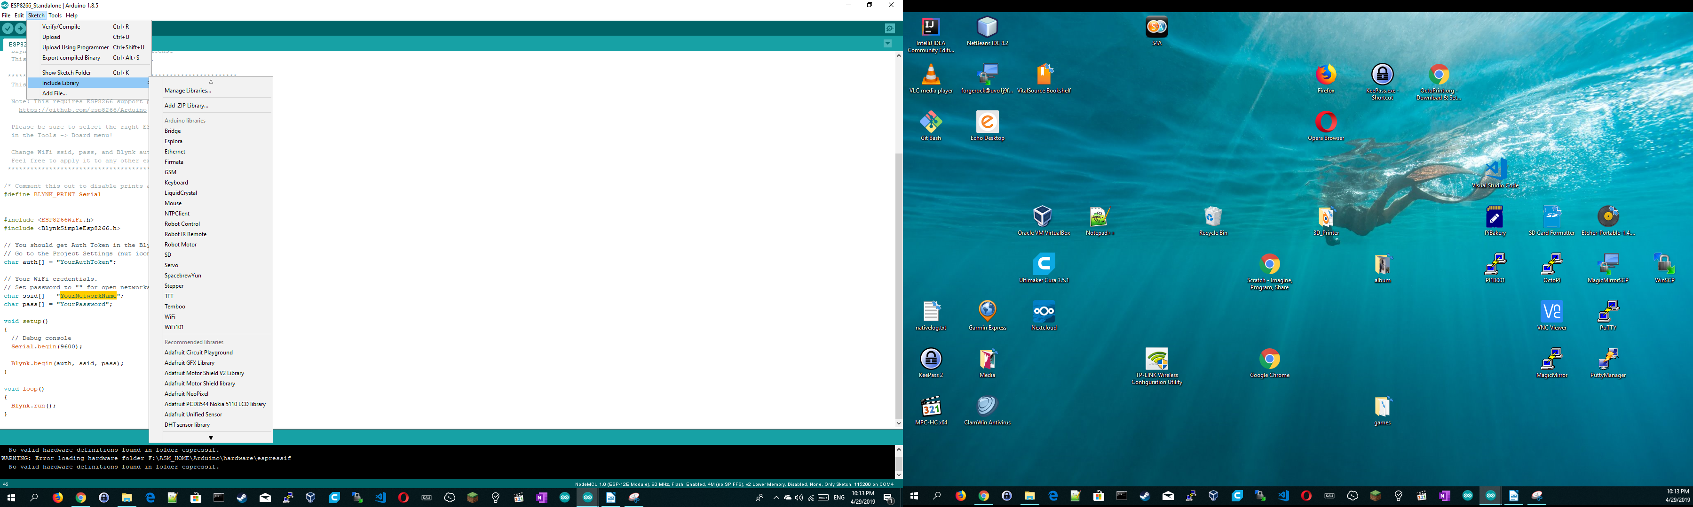

In the Textbox, type in “Blynk” and install the library “Blynk by Voldymyr ...”

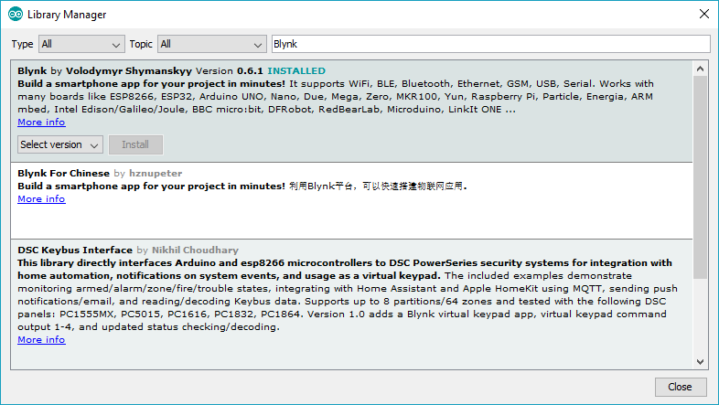

In the Arduino IDE, go to : Files → Examples → Blynk → Boards_WiFi → ESP8266_Standalone

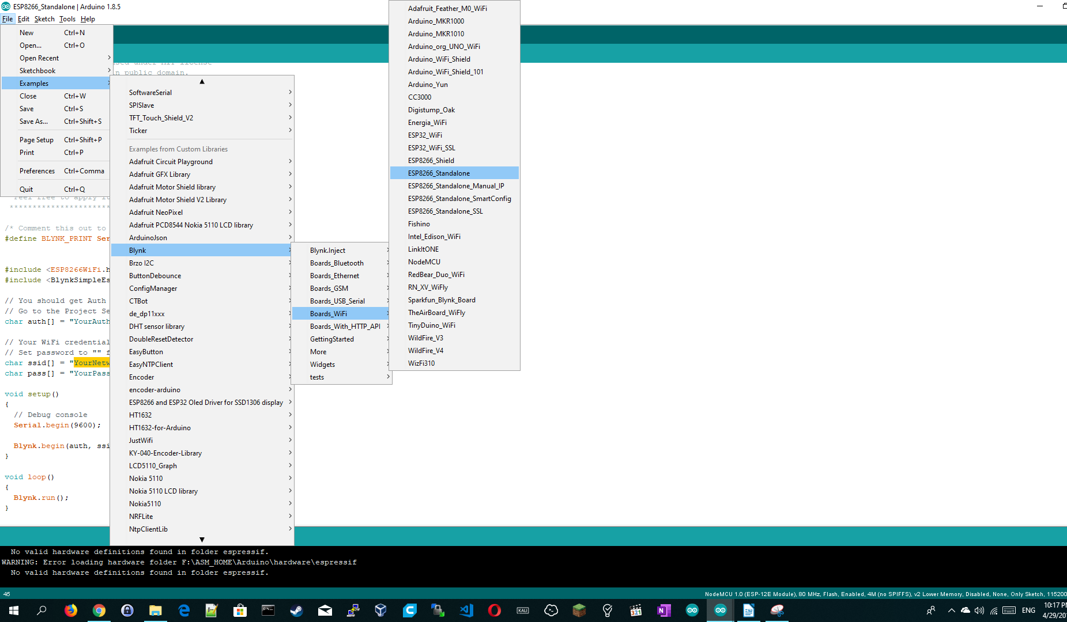

Modify the code accordingly:
char auth[] = "YourAuthToken(You should have this already in the email)";

char ssid[] = "YourNetworkName";
char pass[] = "YourPassword";

compile and upload the sketch.

In the Phone APP , press and unpress the button to notice the led is turning ON (LOW) and OFF(High).

